**CORE COMPETENCIES**

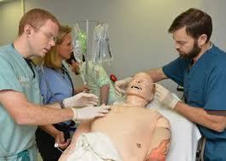



**STRIVE to Thrive:**

The CFMS recommends that all medical students are exposed to the following core competencies through simulation in medical school. These scenarios simulate real life situations that residents may be expected to manage, therefore it is imperative that all medical students have exposure to these stressful events to improve future performance.

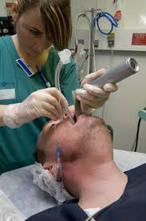

1. **Exposure to a non accidental pediatric trauma**
2. **Activating a code by yourself**
3. **Managing the death of a patient**
4. **Debriefing a suicide attempt**
5. **De-escalating an aggressive patient**
6. **Managing a challenging obstetrical delivery**
7. **Experiencing a team conflict**
8. **Engaging in a difficult procedural skill**
9. **Navigating an ethical dilemma**
10. **Discussing a personal medical error**

The above competencies link to CanMED intrinsic roles as well as CBME based EPAs and objectives of training