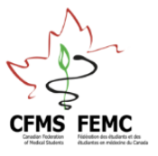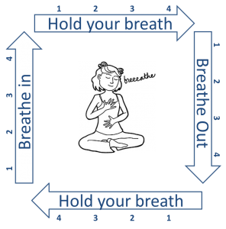**Box Breathing.**

Deep breathing eases up on the “accelerator” effect that stress has and allows us to find our inner “brake.” It is one of the most portable and effective tools we have to turn off the fight or flight response. The number to remember is four: 4 seconds in and out, 4 second breath holds, around 4 breaths a minute, for 4 minutes.

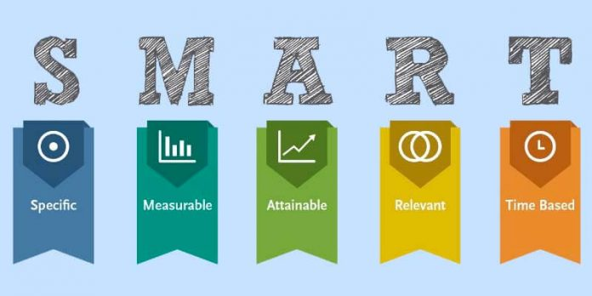

**Goal Setting**

This technique mitigates stress by providing structure and information to the brain, thus, controlling the stress response. The key is to break down tasks into smaller, manageable pieces.

**Visualization**

Used to rehearse situations and skills to prepare for challenges. Both imagined and real-life environments have a powerful effect on our nervous system. With practice, we facilitate the brain’s ability to access relevant information during similar scenarios, creating stronger pathways and quicker responses. Alternatively, visualizing your “happy place” can help overcome anxiety.

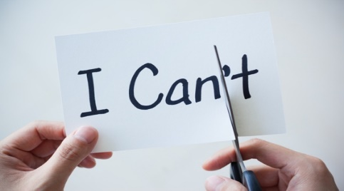**Self Talk**

The key is to remember that just because we think something, doesn’t mean it is true. Self talk is based on Cognitive Behaviour Therapy thought-feeling-behaviour triangle. If you can identify and correct the thought, you can alter the feeling and behaviour.

**Attention Control**

Attention control is the ability to direct one’s full attention to appropriate cues and stay focused on tasks in the present instead of being controlled by irrelevant external (i.e. environmental conditions such as the weather, noise, etc.) or internal (i.e. thoughts, emotions, physiological activity, etc.) stimuli. Short positive cue statements are used in order refocus from distracting stimuli.

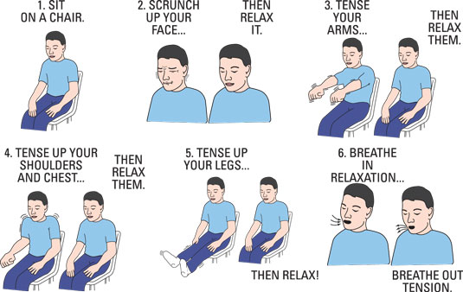

**Progressive Muscle Relaxation**

PMR enhances performance by teaching how to recognize and find the optimal muscle tension for activity. Too much muscle tension leads to performance deficits in mechanics and technique, especially those requiring small motor control.